----------------------------------------------------------------------Write C++/Java program to draw line using DDA and Bresenham‘s algorithm. Inherit pixel class and Use function overloading

----------------------------------------------------------------------#include<stdio.h>

#include<iostream>

#include<stdlib.h>

#include<graphics.h>

using namespace std;

class pixel

{

public:

void plot(int x,int y)

{

putpixel(x,y,11);

}

};

class myline : public pixel

{

float x1,y1,x2,y2,dx,dy,len;

public:

void accept();

void draw();

void draw2();

};

void myline :: accept()

{

cout<<"Enter starting co-ordinates:";

cin>>x1>>y1;

cout<<"Enter ending co-ordinates:";

cin>>x2>>y2;

}

void myline :: draw() //DDA

{

float x,y,xi,yi;

int i=0;

dx=x2-x1;

dy=y2-y1;

len = max(abs(dx),abs(dy));

xi=dx/len;

yi=dy/len;

x=x1+0.5;

y=y1+0.5;

while(i<len)

{

plot(x,y);

x=x+xi;

y=y+yi;

i++;

}

}

void myline :: draw2() //bresenham

{

int dx,d,dy,x,y,xi,yi;

dx=abs(x2-x1);

dy=abs(y2-y1);

x=x1;

y=y1;

if(dx>=dy)//gentle slope

{

d=2*dy-dx;

xi=1;

yi=1;

if(x2<x1)

xi=-1;

if(y2<y1)

yi=-1;

while(1) //gentle slope

{

if(d>=0)

{

d=d+2*dy-2*dx;

plot(x=x+xi,y=y+yi);

continue;

}

if(d<0)

{

d=d+2*dy;

plot(x=x+xi,y);

}

if(x2==x || y2==y)

break;

}

}

if(dy>dx) // steep slope

{

d=2*dx-dy;

xi=1;

yi=1;

if(x2<x1)

xi=-1;

if(y2<y1)

yi=-1;

while(1) //steep slope

{

if(d>=0)

{

d=d+2*dx-2*dy;

plot(x=x+xi,y=y+yi);

continue;

}

if(d<0)

{

d=d+2*dx;

plot(x,y=y+yi);

}

if(x2==x || y2==y)

break;

}

}

}

int main()

{

int gd=DETECT,gm,i;

initgraph(&gd,&gm,"");

myline x;

x.accept();

cout<<"1-DDA\t2-Bresenham\n";

cin>>i;

switch(i)

{

case 1:

cout<<"Using dda";

x.draw();

break;

case 2:

cout<<"Using bvresenham";

x.draw2();

break;

default : cout<<"Wrong Code";

}

delay(6000);

closegraph();

}

**OUTPUT:**

For starting(100,100) endpoint(150,350)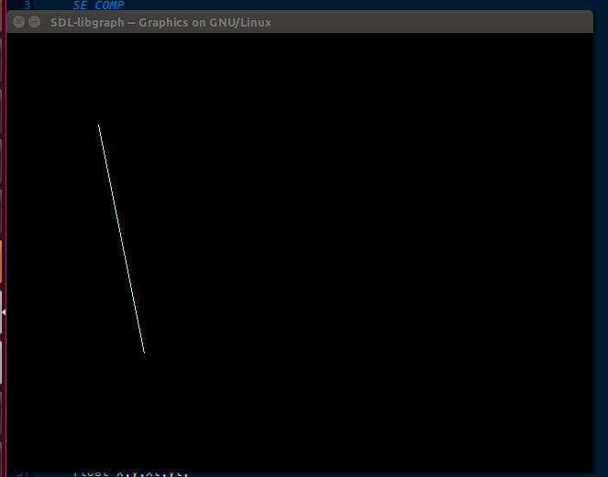

For starting(100,100) endpoint(150,350)

